2021 ACLU of Illinois Legislative Session Toolkit

Overview
With the 2021 Illinois legislative session well in progress, the ACLU of Illinois and our partners are advocating for essential and long-overdue reforms to remove unfair and unjust barriers to police accountability, repeal harmful barriers to reproductive healthcare, update Illinois’ sexual health education standards, protect digital privacy within the home, and more.

We need your help to get these measures passed, so please read on to learn more about these critical legislative initiatives and how you can take action right now to help ensure they are passed. In this toolkit, you will find information and resources to be a digital ambassador for the ACLU of Illinois during this critical legislative session, including:

- Find out when to Take Action (pg. 1)
- Actions to Take (pg. 2)
- Quick Social Media Tips (pg. 2)
- Legislative Initiatives Overview (pg. 3-4)
- Sample Email (pg. 4-5)
- Additional Resources (pg. 5)
- Graphics (pg. 5-6)

I. Find out when to Take Action:
- Look out for urgent emails from the ACLU-IL staff, Actions Alert emails, and People Power emails/texts on actions we need you to take.
- Watch our social media accounts for important bill updates. ACLU-IL social media accounts:
☐ Facebook (@ACLUofIllinois): https://www.facebook.com/ACLUofIllinois/
☐ Instagram (@acluofil): https://www.instagram.com/acluofil/
☐ Twitter (@ACLUofIL): https://twitter.com/acluofIL
- Check for actions in the weekly Communications Update email from Ed Yohnka that are sent on Friday afternoons.
- Resources on our website:
  - Blog with actions for each bill: https://www.aclu-il.org/en/news/take-action-legislation-springfield
  - ACLU-IL Action Page: https://www.aclu-il.org/en/act

II. Actions to Take:
For each of the ACLU of Illinois’ 2021 legislative initiatives, we strongly encourage you to:
- Take action by calling, emailing, or contacting your state legislators on social media (phone numbers and links below) to encourage them to support and sponsor each of the bills; and
- Share information on these critical initiatives with your networks by:
  - Sending emails (example below) encouraging them to take action on these bills, including:
☐ Family
☐ Friends
☐ Colleagues
☐ Professional, Activist and Social Networks
  - Sharing our social media posts with your social networks encouraging them to take action.

III. Quick Social Media Tips
Please tag us on your social media posts:@ACLUofIllinois on Facebook, @acluofil on Instagram, and @ACLUofIL on Twitter!
- Sharing an ACLU of Illinois post on Facebook:
  - Below a post, click the Share in the bottom right.
  - Select where you want to share the post.
  - Add text to your post, if you would like. Click post.
- Sharing an ACLU of Illinois post on Instagram:
  - Go to the post you want to re-share
  - Under the post to the left click on the paper airplane icon.
  - There should be an option to “Add post to your story”. Click here.
  - You will see a preview of what your story will look like. Tag us on your story by clicking the empty space around the post and typing in our handle: @acluofil
  - Click to share to story (on bottom left)
- Adding a link to your Instagram bio:
  - After signing in, go to your profile.
  - There should be an option to “Edit Profile” under your “Bio.”
  - Paste the URL you would like to include in “Website” section.
  - Don’t forget to save by hitting “Done”!
- Turning on Instagram post notifications:
  - Go to the ACLU of Illinois’ profile (@acluofil).
  - Tap the alarm bell icon in the top right hand corner.
  - Select the notifications you would like to receive.
- How to Retweet on Twitter:
  - Tap the Retweet icon.
  - Tap Retweet as Quote Tweet.
  - Add your own comment. Tap Retweet.

IV. Legislative Initiatives Overview:
For more information on any specific initiative, click the hyperlink and it will take you to the bill page.
- HB 1727: The Bad Apples in Law Enforcement Accountability Act: (Rep. Tarver) HB 1727 removes blanket “qualified immunity,” the unfair and unnecessary legal barrier that often blocks courts from holding police officers accountable when they violate a person’s constitutional rights.

Contact your state representative in support of HB 1727:
Call 1-866-581-7519 | Send a message

- HB 2542: Removing Felony Bar for Individuals Seeking a Name Change: (Rep. Cassidy) HB 2542 brings our state’s overly-restrictive name change law, in line with the majority of other states and helps those who are transgender, gender-expansive people and survivors of human trafficking live safer and more authentic lives by removing the ten-year waiting period and the lifetime ban.

Contact your state representative in support of HB 2542:
Call 1-866-957-2612 | Send a message

- HB 2553: Protecting Household Privacy Act: (Rep. Williams) HB 2553 places modest parameters on the collection and use of household electronic data by law enforcement. With the proliferation of these devices – like “Alexa” or a Ring doorbell, there needs to be some rules to protect your private information.

Contact your state representative in support of HB 2553:
Send a message

- HB 3071: Illinois Healthy Youth Act: (Rep. Lilly) HB 3071 updates Illinois’ sexual health education standards to give young people the information and tools they need to support responsible and informed decision making about their health and well-being throughout their lives.

Contact your state representative in support of HB 3071:
Call 1-866-563-5608 | Send a message

- HB 3447: Reducing Barriers to Recovery: (Rep. Ammons) HB 3447 implements a proven public health approach, eliminating the failed policies of the “War on Drugs.” The bill reclassifies the charge for simple possession of all drugs from a felony to a misdemeanor and provides access to drug treatment for those who are arrested.

Contact your state representative in support of HB 3447:
Call 1-866-895-2997 | Send a message

- SB 2190: Repeal PNA: (Sen. Sims) SB 2190 repeals a dangerous law that creates barriers for access to reproductive health care for young people. The Parental Notice of Abortion Act is part of a by-gone era in Illinois, a time when our state passed a series of laws in the 1990s designed to limit access to reproductive health care.

Contact your state senator in support of SB 2190:
Call 1-866-974-8813 | Send a message

- SB 655: HIV: (Sen. Peters) SB 655 repeals the harmful Illinois law that criminalizes people living with HIV. Currently people living with HIV can face the threat of arrest, prosecution, and incarceration without any transmission taking place. Repealing this law would treat HIV like any other chronic disease.

Contact your state senator in support of SB 655:
Send a message

V. Sample Email:
Help expand our outreach on these legislative initiatives by sending the following email to your networks – please feel free to personalize.

Subject Line: Take action on ACLU-IL 2021 Legislative Initiatives

Dear XXX,

I’m reaching out today about the ACLU of Illinois’ legislative initiatives. With the 2021 Illinois legislative session well in progress, the ACLU and our partners are advocating for essential and long-overdue changes to Illinois to remove unfair and unjust barriers to police accountability, repeal harmful barriers to reproductive healthcare, increase alternatives to incarceration and eliminate barriers to reentry, update Illinois’ sexual health education standards, protect digital privacy within the home, and more.

We need your help to get these measures passed, so please read the full legislative agenda here and take action on each of the bills, including:
- HB 1727: The Bad Apples in Law Enforcement Accountability Act: HB 1727 removes blanket “qualified immunity,” the unfair and unnecessary legal barrier that often blocks courts from holding police officers accountable when they violate a person’s constitutional rights. Take action on this bill!

- HB 2542: Removing Felony Bar for Individuals Seeking a Name Change: HB 2542 brings our state’s overly-restrictive name change law, in line with the majority of other states and helps those who are transgender, gender-expansive people and survivors of human trafficking live safer and more authentic lives by removing the ten-year waiting period and the lifetime ban. Take action on this bill!

- HB 2553: Protecting Household Privacy Act: HB 2553 places modest parameters on the collection and use of household electronic data by law enforcement. With the proliferation of these devices – like “Alexa” or a Ring doorbell, there needs to be some rules to protect your private information. Take action on this bill!

- HB 3071: Illinois Healthy Youth Act: HB 3071 updates Illinois’ sexual health education standards to give young people the information and tools they need to support responsible and informed decision making about their health and well-being throughout their lives. Take action on this bill!

- HB 3447: Reducing Barriers to Recovery: HB 3447 implements a proven public health approach, eliminating the failed policies of the “War on Drugs.” The bill reclassifies the charge for simple possession of all drugs from a felony to a misdemeanor and provides access to drug treatment for those who are arrested. Take action on this bill!

Thank you in advance for taking action in support of these critical initiatives to protect and advance the rights of all.

Sincerely,
XXX

VI. Additional Resources
- Our work in Springfield
- Legislative resources
- Podcast Episode: How to Make Your Voice Heard in Springfield
- Find your elected officials
- How a bill become a law in Illinois
- We encourage you to call or schedule a virtual visit with your senator or representative to talk about these bills. Find out more information and tips about meeting with your legislator here and please reach out to us at advocacy@aclu-il.org with any questions.

VII. Graphics
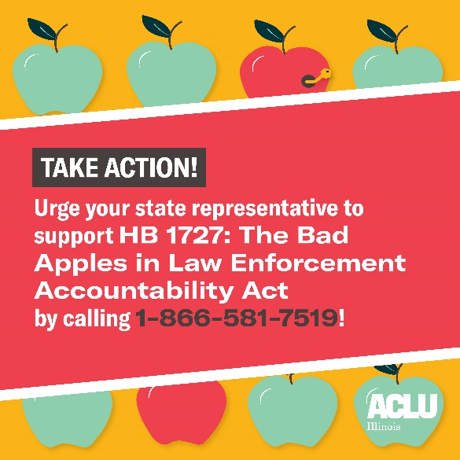
We also encourage you to use the images provided below to post on social media about the ACLU of Illinois’ 2021 Legislative Initiatives. Please tag us on your posts, @ACLUofIL on Twitter, @acluofil on Instagram, and @ACLUofIllinois on Facebook! Pro tip: Include one of the links in the caption so people can find out more about the bill, and other ways to take action.
